EMS Mass Casualty Plan
This Plan is developed to assist first on-scene emergency responders in management of mass casualty incidents. When multiple sites or events occur, each site or occurrence shall be managed through the separate mass casualty incident command structures, until such time as an area-wide command structure can be activated to integrate and coordinate the separate mass casualty incident commands.
This Plan does not replace or negate any mutual aid or other agreement currently in place between various Manitowoc County response agencies.
Submitted By:
Mass Casualty Sub-Committee of
Manitowoc County Local Emergency Planning Committee
Manitowoc County Emergency Management
Updated April 2025 wpm

TABLE OF CONTENTS
Page Number
- Notification of Command/Response 3
Personnel
- Initial Response - First Arriving 3
Ambulance Unit EMS Command Job Description 4
Triage Group Supervisor Job Description 5
Treatment Group Supervisor Job Description 6
Transportation Group Supervisor Job Description 7
Staging Group Supervisor Job Description 8
Appendix "A" Triage 9
Appendix "B" Hospitals 12
SECTION I: NOTIFICATION OF CQMMAND/RESPONSE PERSONNEL BY THE MANITOWOC JOINT DISPATCH CENTER (JDC)
A. Upon receipt of information indicating a potential mass casualty incident by Joint Dispatch Center (JDC), the dispatcher shall follow their task sheet.
SECTION II: INITIAL RESPONSE: FIRST IN Medical Personnel

The first-in Medical Personnel shall remain on-scene and assume all EMS-related scene command functions until relieved, or all patients are cleared from the mass casualty incident scene.
- The Crew Chief of the first arriving Medical Personnel will assume the role of the EMS Command and determine if the incident is an MCI and maintain that position until relieved and shall:
- Identify the scene is safe for responders to enter the incident.
- Once determined the incident is an MCI. EMS command shall declare the incident an MCI unless already declared
- Establish a command post and identify a primary communications frequency to coordinate all EMS command functions.
- Identify with JDC a staging area and channel incoming units should communicate with the Staging Officer on. Request Life safety card early in scene.
- EMS command may identify other radio frequencies as needed.
- Establish triage, treatment, transport, ambulance and equipment staging areas, and assign subordinate command personnel upon availability including a Triage Group Supervisor.
- Coordinate activities with other emergency agencies including Fire, Police, Public Works and Emergency Management (Unified Command) as needed.
- All triage shall be coordinated in accordance with accepted medical practices. Triage tags shall remain with patient's medical record for a minimum of forty-eight (48) hours. The triage tag identification system adopted for Manitowoc County shall be kept on each responding EMS rig. Extra tags are available at Emergency Management (EM).

EMS COMMAND JOB DESCRIPTION
It is the responsibility of the EMS COMMAND to:
- Declare Mass Casualty Incident and assign group supervisors as needed by the scope of the incident.
- Survey the scene upon approach to determine the magnitude of the situation and presence of hazards, (i.e. downed power lines, hazardous materials spills, fire, Secondary devices or other hazards).
- Request Command Post and mass casualty trailer to the scene.
- Don EMS command vest when available.
- Obtain a count of the total number of patients and determine severity in terms of numbers of critical (RED), Serious (YELLOW), Expectant (Grey), and Minor (GREEN) from Triage Group Supervisor.
- Confer with the Triage Group Supervisor upon completion of triage sweep to determine what additional resources are needed (ambulance, rescue units, personnel, EMS helicopters, buses, etc.)
- Determine if there is a need to establish a Unified command post.
- Organize the scene by functional areas. This includes organizing the incident area(s), treatment area(s), transport area(s), and staging area(s). Materials for marking treatment area(s) are stored in the Mass Casualty trailer stored at the Two Rivers Fire Department.
- Appoint Group supervisors, for each area as additional personnel arrive. A group supervisor will be assigned for; Staging, Triage, Treatment, Transport
L. Scene/hospital communication is the responsibility of the transport group supervisor.
Appoint a Staging Group Supervisor and designate a staging area
Appoint a Treatment Group Supervisor.
Appoint Triage Group Supervisor and liaison if needed
Appoint a Transportation Group Supervisor.

EMS TRIAGE GROUP SUPERVISOR JOB DESCRIPTION
The EMS command shall immediately appoint an Initial Triage Group Supervisor from the crew of first- in ambulance, or First Responder agency whose responsibilities shall be as follows:
- Put on "Triage" vest when available.
- Provided the area is safe, conduct an immediate triage sweep of the scene to count the number of patients by triage category.
- During the initial triage sweep, count the number of patients in each category such as patients tagged red (critical), yellow (serious), green (minor), Gray (Expectant) or black/white (DOA). Apply triage tag to patients. (Tie or Tape). The initial set of tags shall be contained in every EMS vehicle.
- Confer with the EMS Command the number and severity of the injured patients and advise if additional resources are needed
- At the end of each triage sweep of the scene, inform the EMS Command of the latest patient count by color.
I. Continually repeat triage until all patients have been cleared from scene.

TREATMENT GROUP SUPERVISOR JOB DESCRIPTION
- Identify the Treatment Area, notify EMS command.
- Wears "Treatment" vest when available.
- Secures tarps labeling treatment areas and request treatment area carts as designated by color to be brought from Mass Casualty trailer. Ensures the safety of patients and EMS personnel with assigned treatment areas.
- Assigns personnel to patient care duties and identifies EMS equipment needs to render care within treatment area. Assigns personnel to patients and assures that triage tag information is filled out on each tag, name, DOB at minimum. Re-evaluate patients to assure patients are transported in an appropriate order.
- Coordinates evacuation of patients with Transportation Group Supervisor to appropriate hospital.

TRANSPORTATION GROUP SUPERVISOR JOB DESCRIPTION
- Reports to EMS Command and/or EMS Triage Group Supervisor
- Wears "Transportation" vest.
- With approval and concurrence of EMS Command and EMS Triage Group Supervisor establishes:
- Patient loading area
- Establishes communications contact with Staging Group Supervisor and advises number of ambulances and special service equipment needed to perform patient transport as well as resources needed to safely move patients from areas within the incident
- Coordinates ambulance routing and response to ambulance transport staging area. May require setting up special routes for ambulances to enter and leave staging areas. Attempt to keep ambulances moving forward. Anytime an ambulance moves in reverse a spotter is required.
- Establishes communications contact with Emergency Operations Center (if activated), and area hospitals to determine area hospital's capabilities to receive patients.
- Maintains patient information and destination.
- Transportation Group Supervisor will be in charge of routing patients.
- Consider sending minor patients to local clinics so hospitals are not overwhelmed with minor patients.

L. Call for helicopters early. Theda Star Dispatch 1-800-236-2066

Hospital Phone Numbers:
Holy Family Memorial Aurora Medical Center Calumet Medical Center Sheboygan Memorial St. Nicholas Hospital, Sheboygan St. Vincent Hospital, Green Bay Aurora BayCare, Green Bay Bellin Hospital, Green Bay Theda Clark, Neenah
920-684-4285
920-794-8562
920-849-7527
920-451-5553
920-451-7288
920-433-0312
920-288-4070
877-235-5461
920-738-6310

STAGING GROUP SUPERVISOR JOB DESCRIPTION
- Wears "Staging" vest.
- Sets up staging area, preferably in a large lot about 2-3 blocks away from incident.
- Works with EMS Chief, and other Supervisors to coordinate the dispersal of available resources including people and vehicles.
- Keeps track of personnel reporting to staging area. Keeps track of where personnel are sent.
- Directs incoming resources to needed areas including setting up an equipment drop.
- Responsible for keeping a log EMS personnel on scene.
- Name
- Unit affiliation
- Task
- Time arrived
- Time dismissed
- Mabas tags are preferred

APPENDIX A
Start Triage Flow Chart
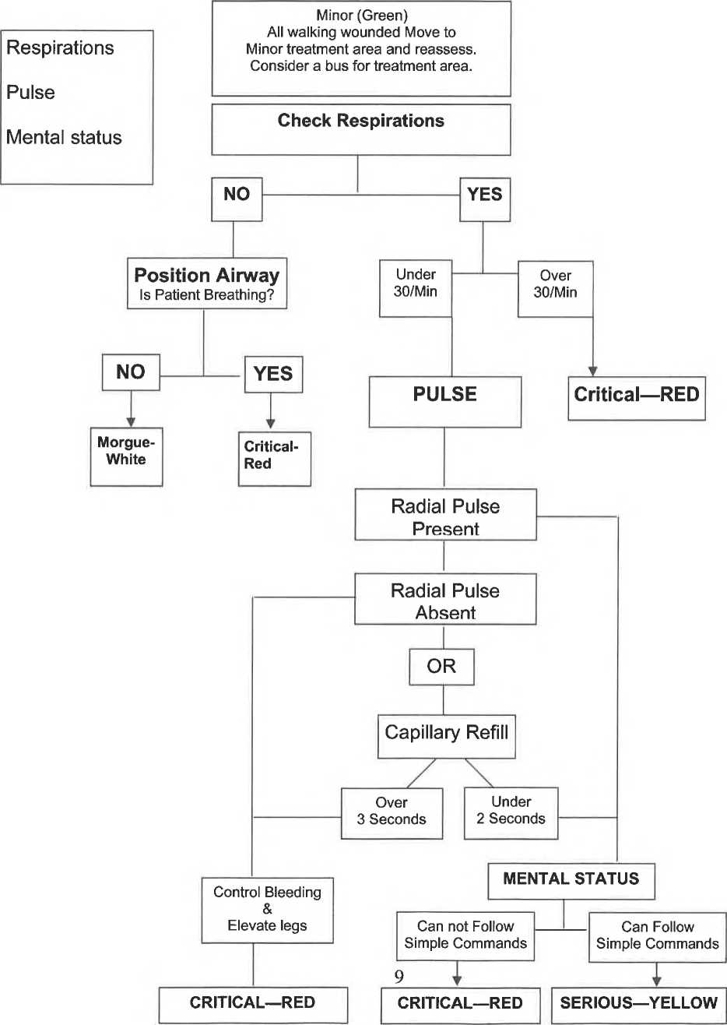

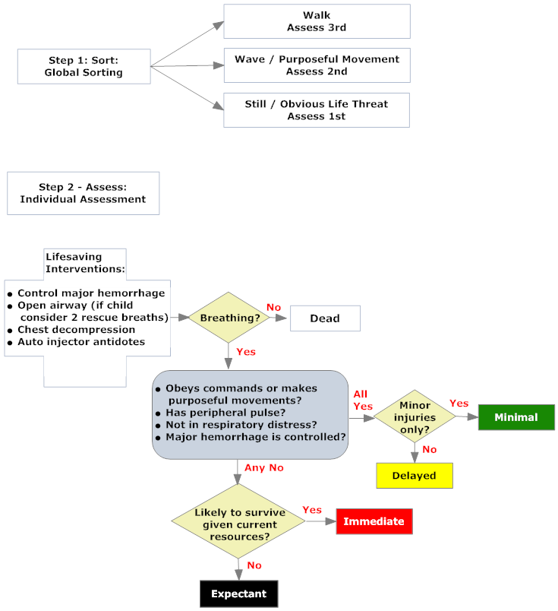
SALT TRIAGE

Definitions:
- RED TAG PATIENTS (Critical or Immediate)
Patients that are salvageable may return to society as they were prior to event.
- YELLOW TAG PATIENTS (Serious-Second Priority)
Patients that require medical care, but several hours will not result to loss of life or limb.
- GREEN TAG PATIENTS (Minor- Last priority)
They are ambulatory and may be directed away from the treatment site and might be directed to a clinic for an assessment or simple treatment.
- WHITE/BLACKTAG PATIENTS (DOA)
Patients whose injuries are so extensive that even with optimal care, the prognosis for recovery or restoration of normal function is poor. They should receive simple "custodial care" and be kept as comfortable as possible if personnel permit.
Note Grey tab are expectant patients meaning they are alive but probably will not survive. Transport these patients last.

Fire Staging
Call Dispatch for additional manpower based on number injured
Call Theda Star Dispatch and ask them to send an appropriate number of Helos
One helo to each hospital (800) 236-2066
Remaining helos to Airport or designated LZ
Align police fire and ambulances in Staging
Set up an equipment drop
Collect from Ambulances as they arrive:
RTF Packs
RTF Ballistic gear
Mega movers
Pre-stage at least 2 rtfs ready to go
Move RTFs and Contact teams with 6 person engines or equipment vans
Send Units with Location, Mission, and Radio Freq
Send Ambulances with Location of AEP, Number of Pts, Transport to
GOAL-Get RTFs to Incident within 11 minutes of first Contact Team

Call area hospitals for how many red, yellow, and green they can handle
 | Hospitals | Red Availability |  |  |  |  |  | Yellow Availability |  |  |  |  |  | Green Availability
 | Aurora Manitowoc County- 920-794-8562 | 1 | 2 | 3 | 4 | 5 |  | 1 | 2 | 3 | 4 | 5 |  | 1 | 2 | 3 | 4 | 5
 | HFM Froedtert 920-684-4285 | 1 | 2 | 3 | 4 | 5 |  | 1 | 2 | 3 | 4 | 5 |  | 1 | 2 | 3 | 4 | 5
 | Baycare 920-288-4070 | 1 | 2 | 3 | 4 | 5 |  | 1 | 2 | 3 | 4 | 5 |  | 1 | 2 | 3 | 4 | 5
 | St Vincents 920-433-0312 | 1 | 2 | 3 | 4 | 5 |  | 1 | 2 | 3 | 4 | 5 |  | 1 | 2 | 3 | 4 | 5
 | Theda Clark Neenah 920-729-2480 | 1 | 2 | 3 | 4 | 5 |  | 1 | 2 | 3 | 4 | 5 |  | 1 | 2 | 3 | 4 | 5
 | St Nicks 920-451-0019 | 1 | 2 | 3 | 4 | 5 |  | 1 | 2 | 3 | 4 | 5 |  | 1 | 2 | 3 | 4 | 5
 | Sheboygan Aurora 920-451-0019 | 1 | 2 | 3 | 4 | 5 |  | 1 | 2 | 3 | 4 | 5 |  | 1 | 2 | 3 | 4 | 5
 | St Mary's Green bay 920-498-8842 | 1 | 2 | 3 | 4 | 5 |  | 1 | 2 | 3 | 4 | 5 |  | 1 | 2 | 3 | 4 | 5
 | Bellin Green bay 920-433-6007 | 1 | 2 | 3 | 4 | 5 |  | 1 | 2 | 3 | 4 | 5 |  | 1 | 2 | 3 | 4 | 5
 | Theda care Appleton 920-738-6310 | 1 | 2 | 3 | 4 | 5 |  | 1 | 2 | 3 | 4 | 5 |  | 1 | 2 | 3 | 4 | 5
 | St Elizabeths 920-738-2108 | 1 | 2 | 3 | 4 | 5 |  | 1 | 2 | 3 | 4 | 5 |  | 1 | 2 | 3 | 4 | 5
 | Calumet Medical Center 920-849-7526 | 1 | 2 | 3 | 4 | 5 |  | 1 | 2 | 3 | 4 | 5 |  | 1 | 2 | 3 | 4 | 5
 | Aurora Grafton 262-377-6019 | 1 | 2 | 3 | 4 | 5 |  | 1 | 2 | 3 | 4 | 5 |  | 1 | 2 | 3 | 4 | 5

